PRAS Accounts Payables
Standard PO Matching
Manual (R12)

Client:
Shared Service Center
Finance and Accounting Department

Author:
Creation Date: January 8, 2015
Last Updated: January 8, 2015
Control Number and Version are marked by a Word Bookmark so that they can be easily reproduced in the header and footer of documents. When you change either of these values, be careful not to accidentally delete the bookmark. You can make bookmarks visible by selecting Tools->Options…View and checking the Bookmarks option in the Show region.

PROCEDURE DETAILS

Log in into Oracle Application 11i using your Username and Password

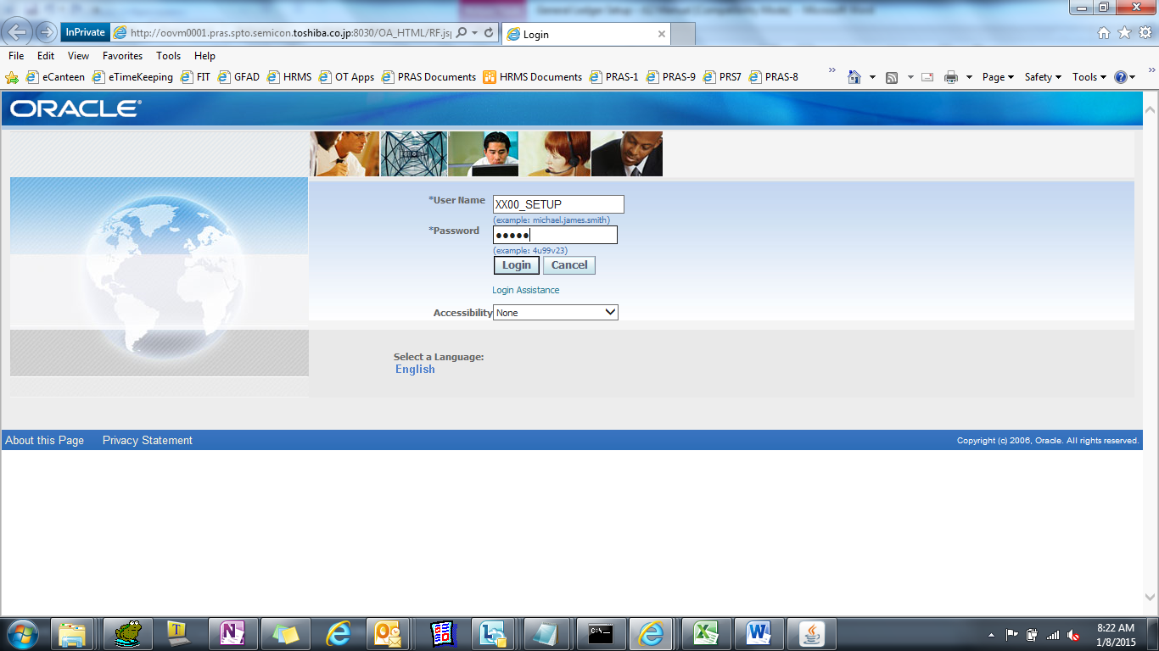

Select TIP AP Add On Systems Responsibility

Check PO
(N)

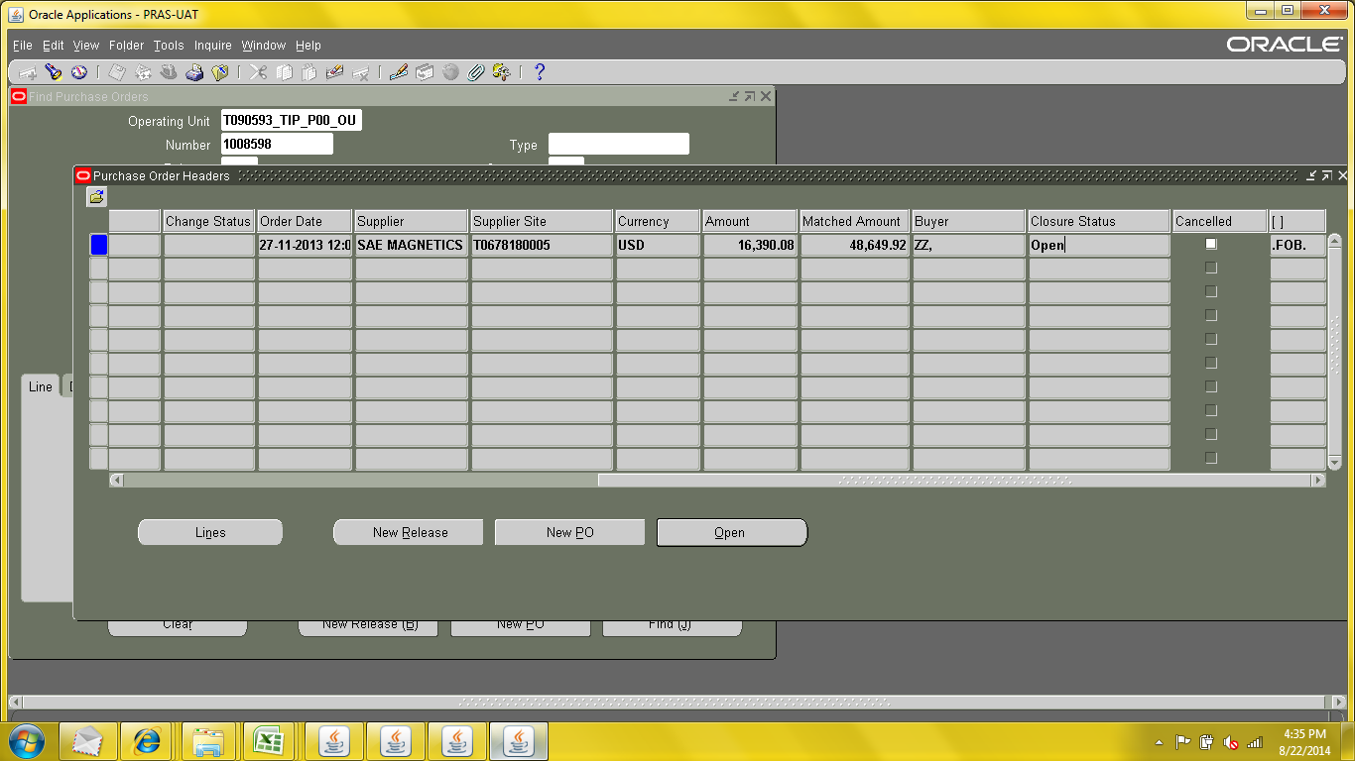

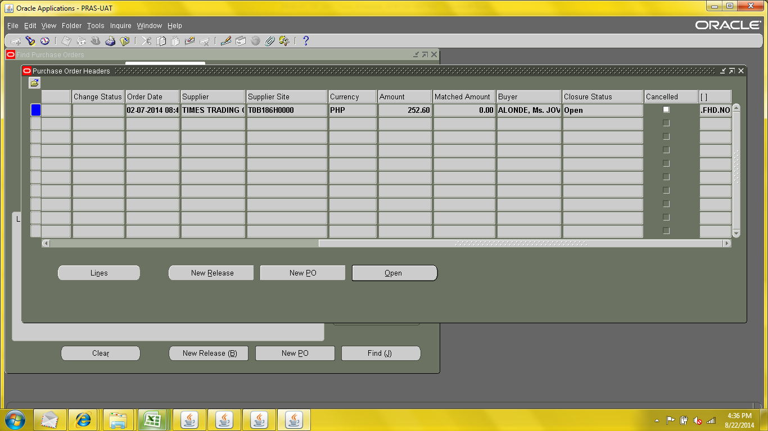

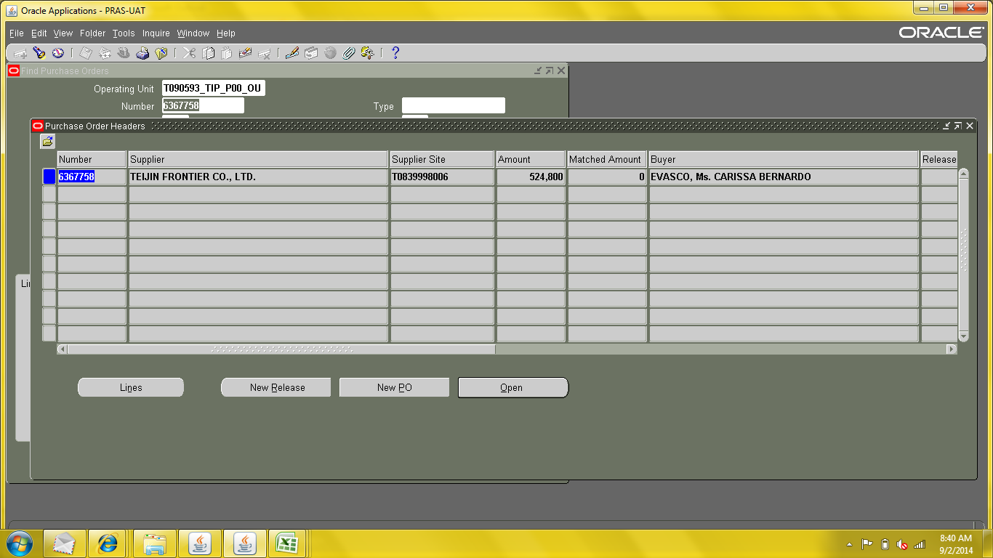

Create Invoice Batch

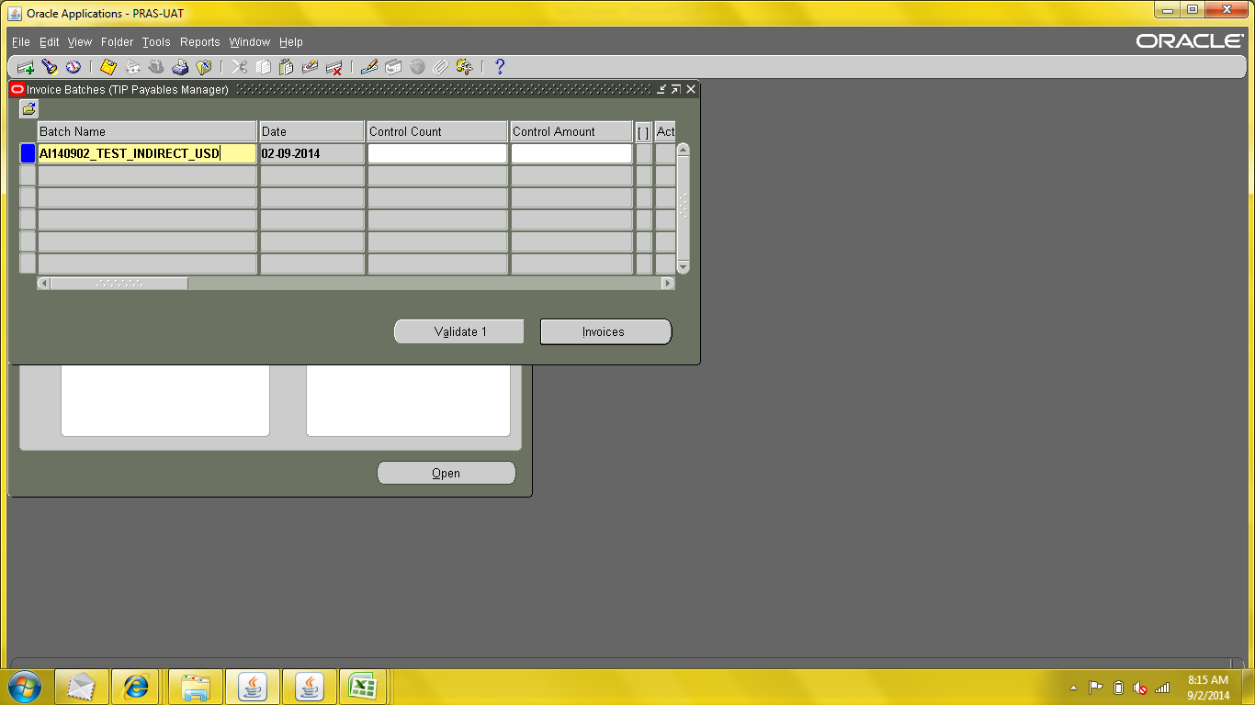

Create Invoice

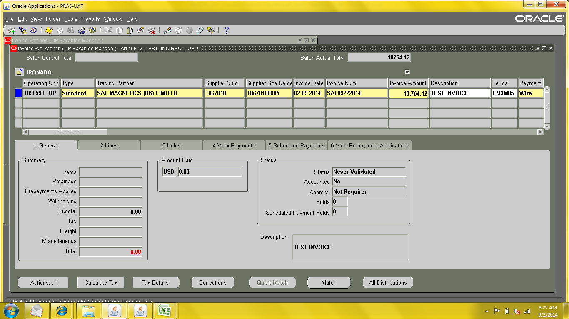

Match PO
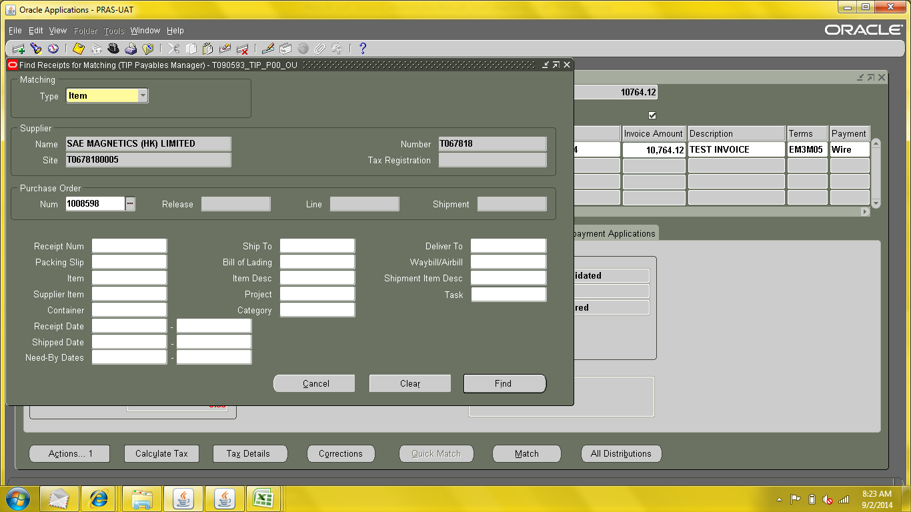

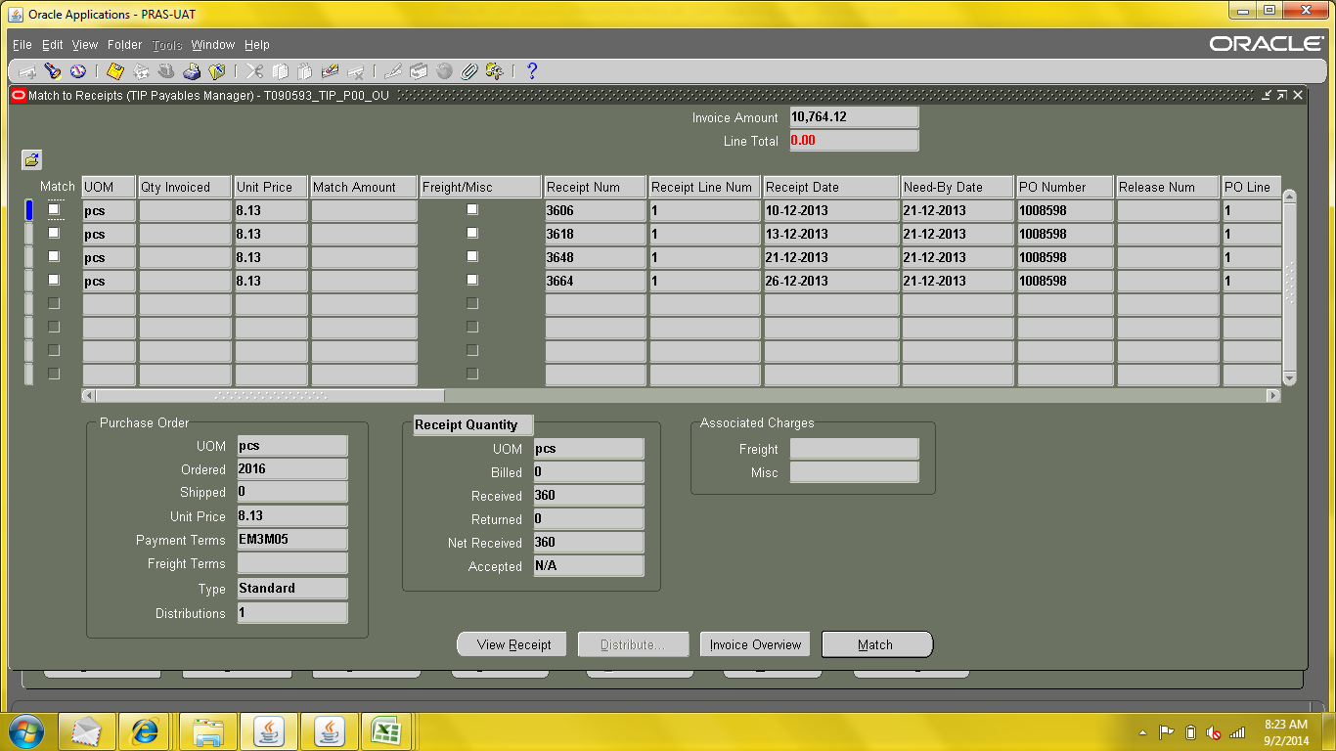

Tick batch for items to be matched.
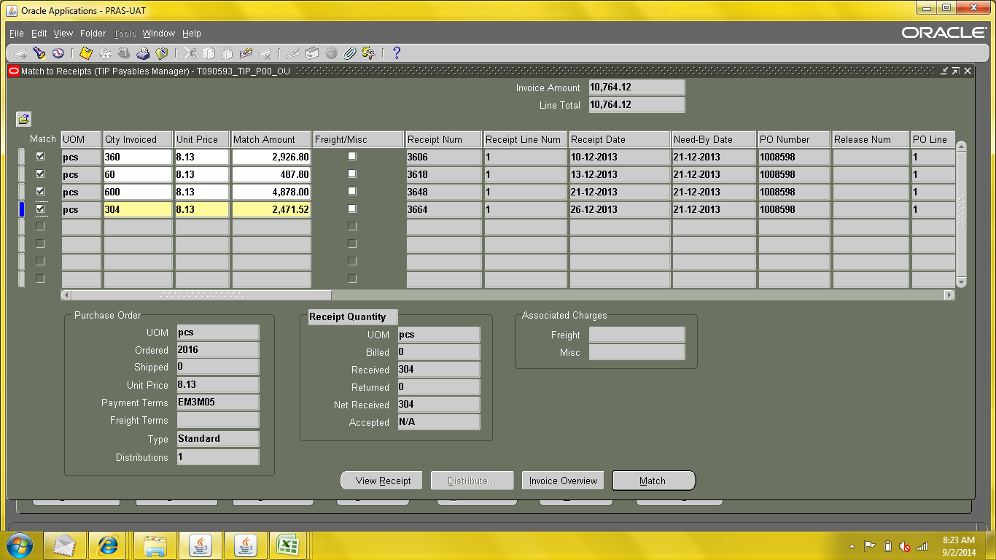

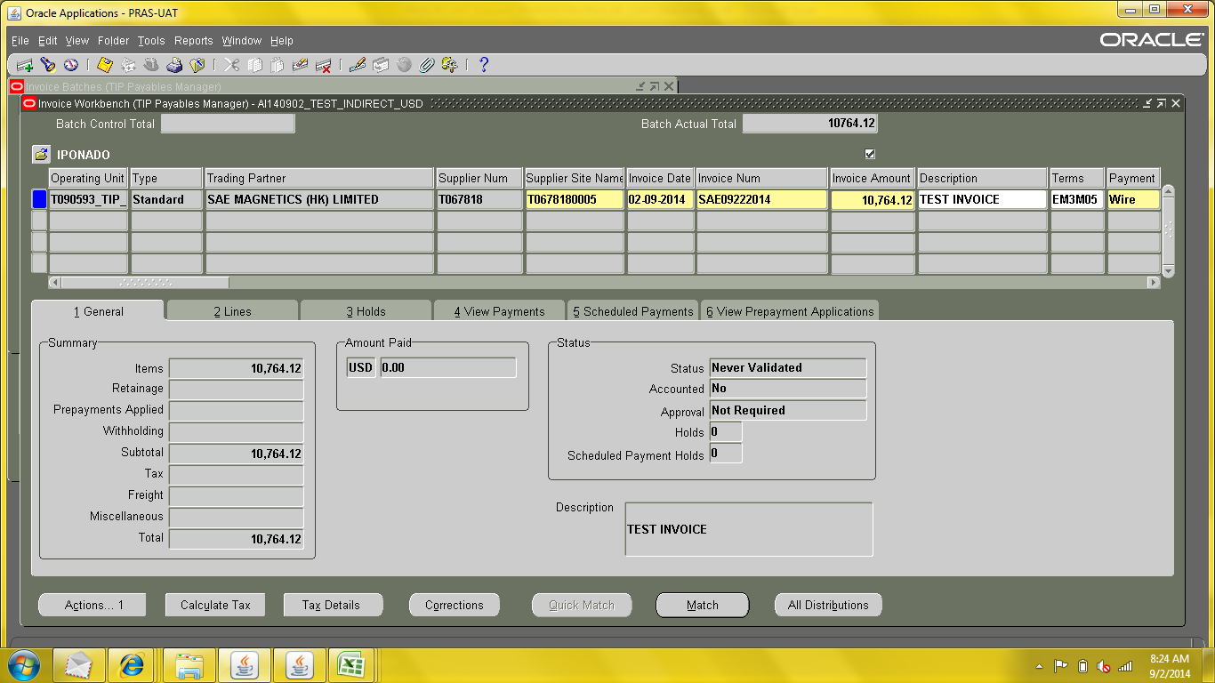

Check Lines and Distributions
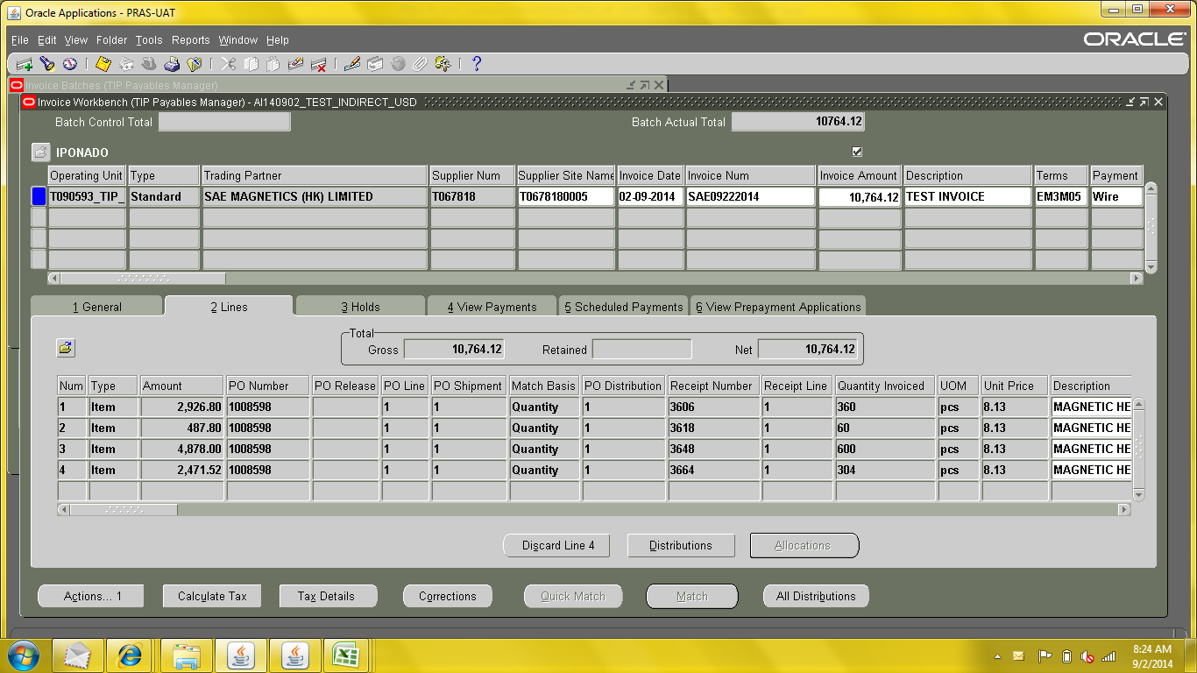

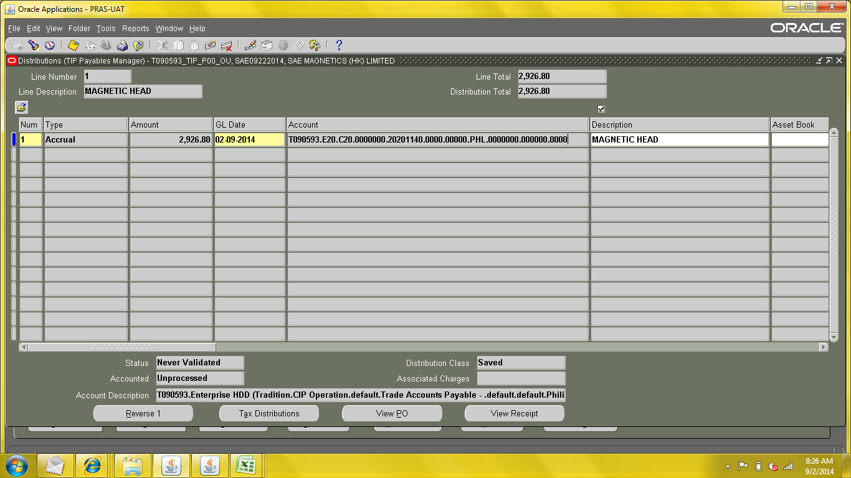

Invoice Validation 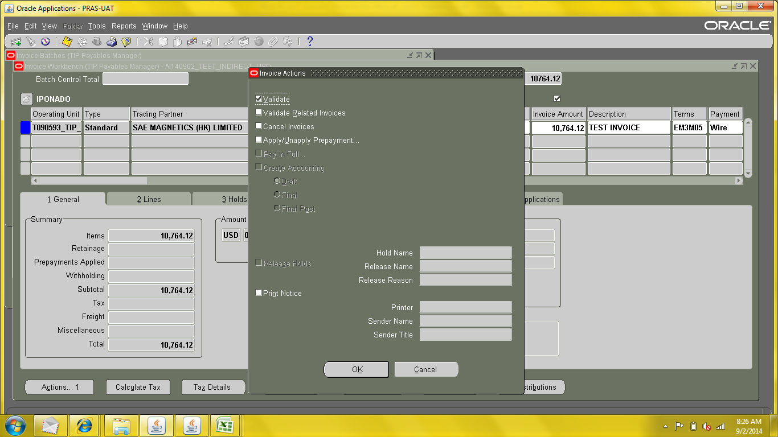

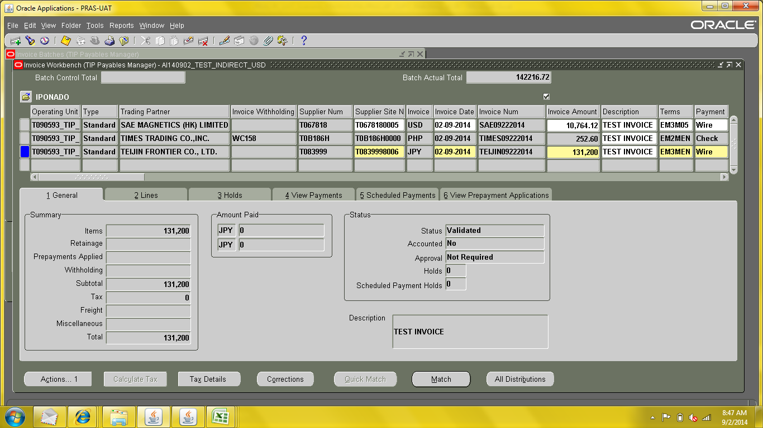

Invoice Create Accounting
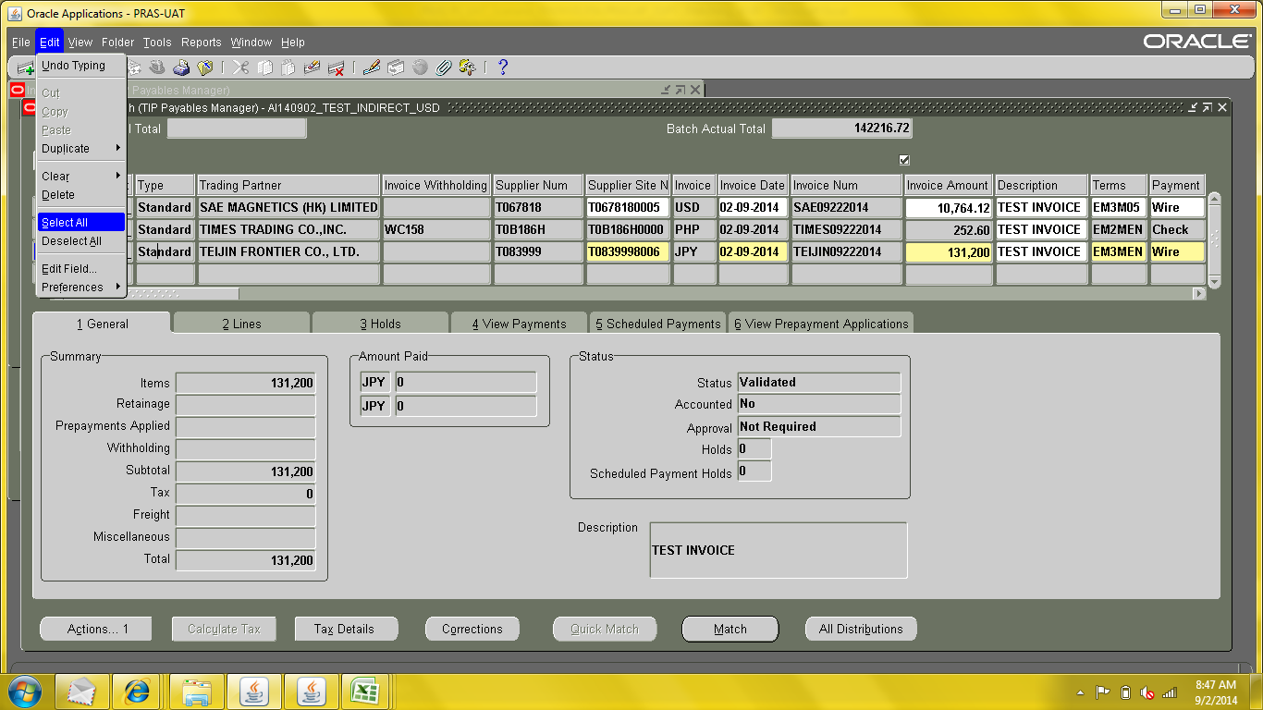

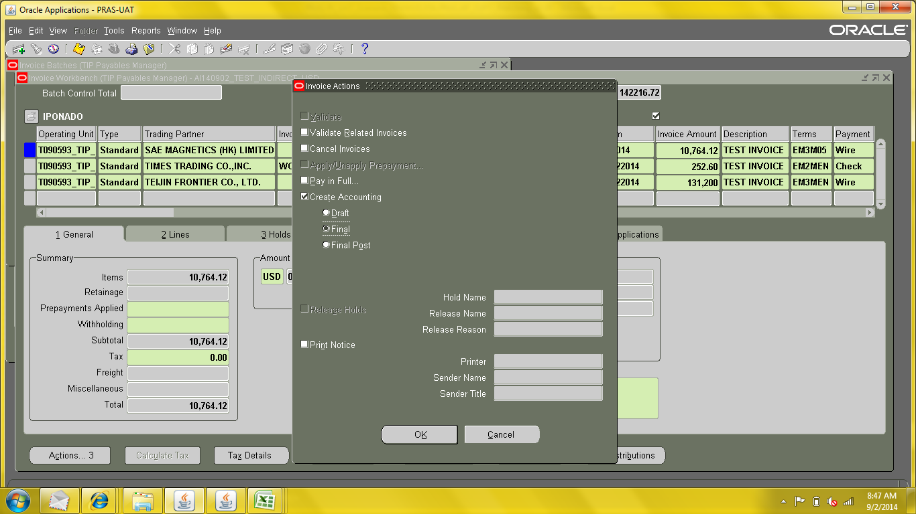

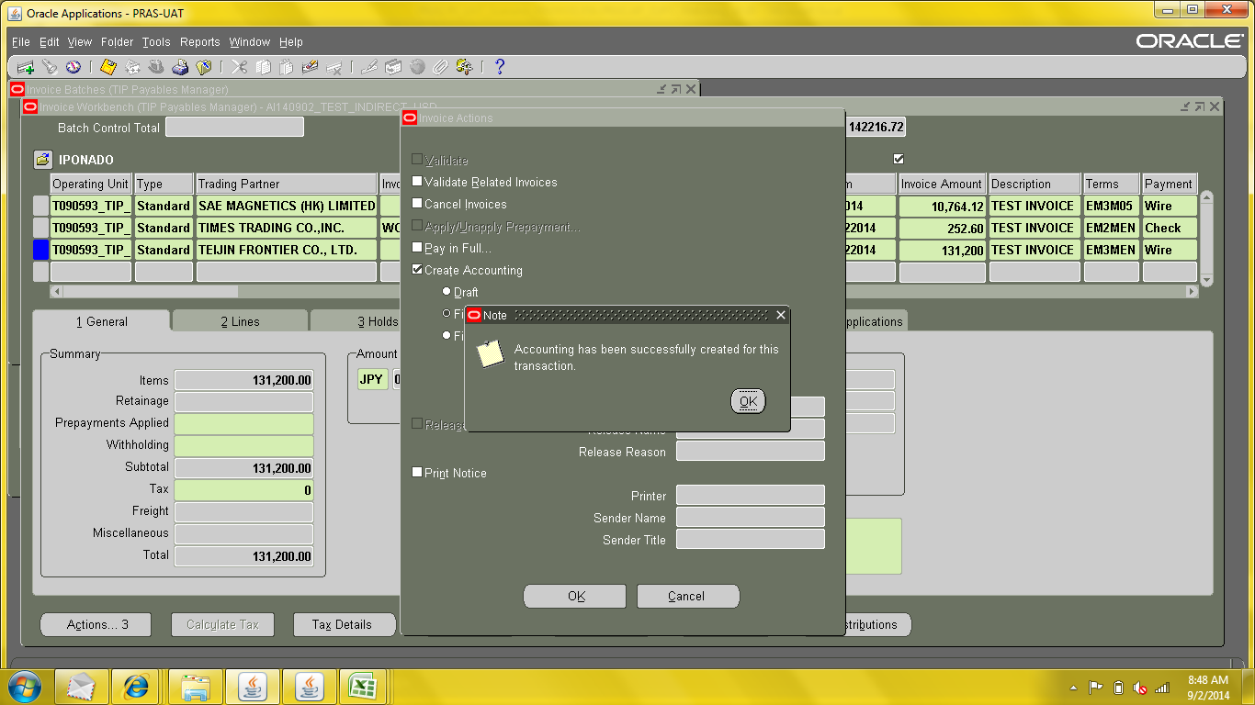

Run TIP Purchase Journal Report
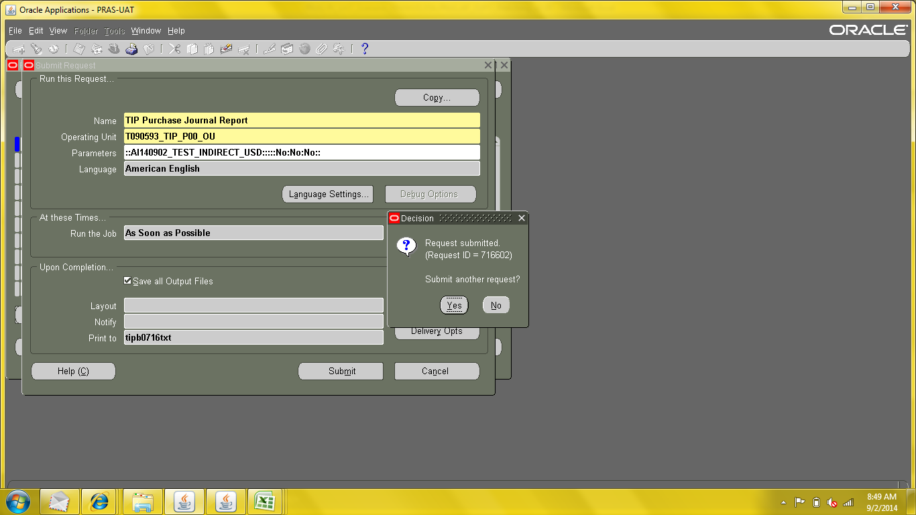

>> Proceed with GAIA Interfacing.

